**WELCOME**

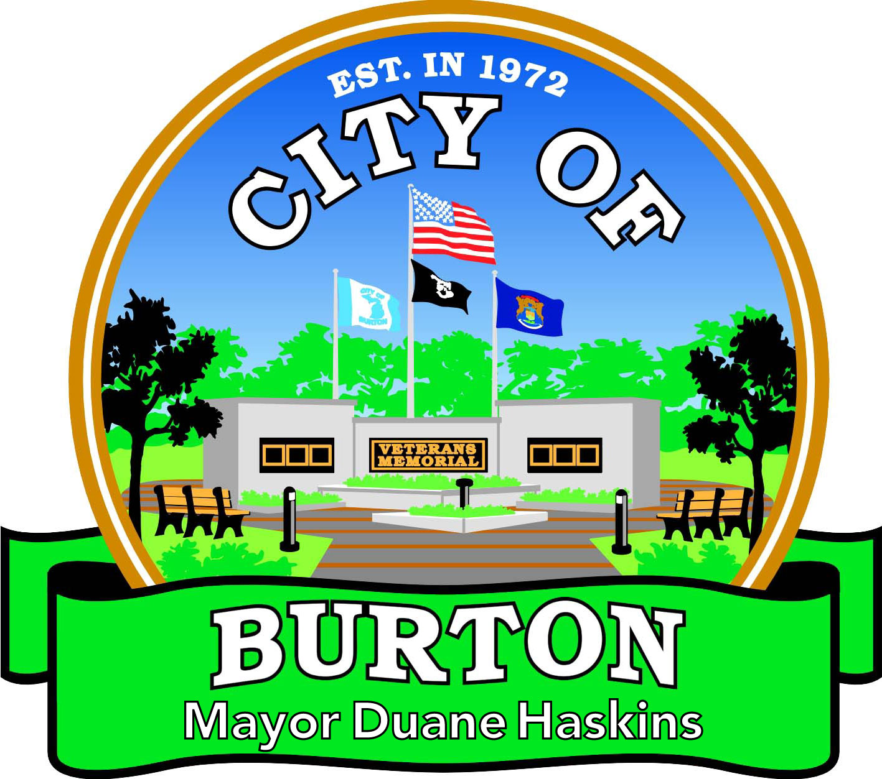

**2024 Resident Information Packet**

4303 S. CENTER RD. BURTON, MI 48519

PH: (810) 743-1500 FAX: (810) 743-5060

<http://www.burtonmi.gov> Updated 01/01/2024



City of Burton

4303 SOUTH CENTER ROAD  BURTON, MI 48519

PHONE (810) 743-1500  FAX (810) 743-5060  www.burtonmi.gov

Dear Neighbor:

I would like to welcome you to the City of Burton. The City of Burton, formerly known as Burton Township, was established in 1972. Through the years, our City has grown in so many ways, making it a great place to live, work and raise your family.

This resident information packet is your one stop shop for all City of Burton information. The resident information packet highlights our administrative staff, our city council members and meeting schedules. There is also information on waste pickup, recycling and permits for fire and dumping, etc. We hope this information can help you better navigate what our beautiful city offers. If you have any questions, feel free to contact City Hall, Monday through Friday 9:00 a.m. to 5:00 p.m. at (810)743-1500.

Sincerely,

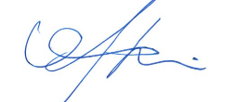

Mayor Duane Haskins

# **DEPARTMENT OF PUBLIC WORKS**

# 4093 MANOR DR.

# BURTON, MI 48519

# Hours of Operation: Monday-Friday

# 8:00am-4:00pm

# Building

# Code Enforcement

# Engineering

# Major and Local Roads

# Planning, Zoning

# Utilities Service

# **BURTON CITY HALL**

# 4303 S. CENTER RD.

# BURTON, MI 48519

# Hours of Operation: Monday-Friday

# 9:00am-5:00pm

# Mayor’s Office

# Assessor’s Office

# Clerk’s Office

# Controller’s Office

# Human Resources Dept.

# Treasurer’s Office: (Invoice, Water, Sewer & Tax Bills)

# 

**Burton City Offices are located on S. Center Rd., North of Maple Rd. and South of Bristol Rd.**

**STAFF**

**MAYOR DUANE HASKINS**

(810) 743-1500

**CLERK RACHEAL BOGGS**

(810) 743-1500

**BENEFITS DEJA SCOTT**

(810) 743-1500

**TREASURER ALICE BRYCE**

(810) 743-1500

**ASSESSOR ANN ABBEY**

(810) 743-1500

**HUMAN RESOURCES**

(810) 743-1500

**DPW DIRECTOR CHARLES ABBEY**

(810) 743-1500

**SENIOR CITIZEN’S DIRECTOR JEAN JOHNSON**

(810) 744-0960

**POLICE CHIEF BRIAN ROSS**

(810) 742-2542

**FIRE CHIEF KIRK WILKINSON**

(810) 742-2158

**CITY ATTORNEY AMANDA ODETTE**

(810) 767-6860

**COUNCIL MEMBERS**

**GREG FENNER, COUNCIL PRESIDENT** (**810) 922-5915**

Central Communication 911 Consortium g.fenner@burtonmi.gov

**GREG HULL, VICE PRESIDENT (608) 443-9169**

Legislative Committee - Chair ghull@uwalumni.com

Metropolitan Alliance Committee - Chair

Planning Commission - Council Representative

**VAUGHN SMITH, COUNCIL (810) 516-9614**

Finance Committee - Chair [v.smith@burtonmi.gov](mailto:v.smith@burtonmi.gov)

Zoning Board of Appeals

**CHRISTINA HICKSON, COUNCIL (810) 391-1949**

Finance Committee Christinafitchetthickson@gmail.com

LED Committee - Chair

Metropolitan Alliance Committee - Alternate

**STEVE HEFFNER, COUNCIL (810) 743-4615**

Economic Development Committee s.heffner@burtonmi.gov

LED Committee

Solid Waste & Recycling Committee

**GARY WINES, COUNCIL (810) 919-2109**

Finance Committee g.wines@burtonmi.gov

Legislative Committee

Parks and Recreation Commission – Council Representative

**CANDICE MILLER (810) 542-4555**

Burton Library Committee c.miller@burtonmi.gov

Economic Development Committee – Chair

LED Committee

Legislative Committee

**2024 COUNCIL**

**MEETING SCHEDULE**

Council meetings are held on the 1st & 3rd Monday of each month

(Unless otherwise indicated)

*\*Please Note Change in Schedule\**

Alternate meeting date due to the following: **January 8, 2024**

(Change due to city offices closed for holiday break December 22, 2023 through January 3, 2024)

**January 22, 2024**

(Change due to Martin Luther King Jr. Day Monday,

January 15, 2024)

**August 8, 2024**

(Change due to day before Primary Election Monday,

August 5, 2024)

**September 5, 2024**

(Change due to Labor Day on Monday, September 2, 2024)

**November 7, 2024**

(Change due to day before General Election Monday, November 4, 2024)

**December 5, 2024**

(Change due to 1st day returning from Thanksgiving break Monday, December 2, 2024)

|  |  |  |  |
| --- | --- | --- | --- |
|  | | | |
| January 8* & 22* | 7:00 PM | July 1 & 15 | 7:00 PM |
| February 5 & 19 | 7:00 PM | August 8* & 19 | 7:00 PM |
| March 4 & 18 | 7:00 PM | September 5* & 16 | 7:00 PM |
| April 1 & 15 | 7:00 PM | October 7 & 21 | 7:00 PM |
| May 6 & 20 | 7:00 PM | November 7* & 18 | 7:00 PM |
| June 3 & 17 | 7:00 PM | December 5* & 16 | 7:00 PM |

**\*Alternate Meetings Date**

**OTHER MEETINGS Each Month**

Planning: 2nd Tues. 5:00 pm Parks & Rec: 2nd Wed. 5:30 pm

DDA: 3rd Mon. 8:30 am ZONING: 3rd Thurs. 5:00 pm

**EMTERRA**

**1606 E. Webster Rd.**

**Flint, MI 48505**

(810) 667-4885

***CURBSIDE WASTE REMOVAL RULES***

* Garbage must be at the edge of the road, outside the ditch line, by **6:00 a.m.** on the day of collection.
* You may have an unlimited amount of garbage bags within reason. The size of the garbage bags may only be 35 gallons or less. All trash must be properly contained and tied up.
* **Trash must be bagged and not loose in containers. (Please use proper trash bags).**
* If raining please make sure can is not full of water as it may freeze during winter months and become too heavy for pick up, bags become frozen to the can making it impossible for the pickup.
* Each Burton household will receive one (1) free dump permit per month.
* You are allowed to set out one (1) large item per week on your normal trash day if it is **under 50lbs and two people can lift it**.
* **If this is a whole house clean out resident must use a dump permit available inside City Hall.**

**ACCEPTABLE ITEMS INCLUDE:**

* Couches, chairs, tables, televisions, washers, dryers, stoves, box springs.
* LATEX paint cans (must be dried out with kitty litter or sand (lid off)
* **Oil Paint is considered Hazardous Waste and will not be picked up.**
* Carpet (rolled and tied in bundles under 4ft. in length, 45lbs. or less, no more than 8 rolls per week),
* Mattresses (folded over and tied).

**\***Refrigerators, freezers, and air conditioners will be picked up at the curb with Freon removed and the service company who removed it attaches a sticker with date of removal.

**UNACCEPTABLE ITEMS INCLUDE:**

* Chest freezers
* Cast iron tubs, cement, concrete, rocks
* Oil paint, oils
* Tires
* No nails or screws
* LUMBER-Demolition material

All material must be bagged or tied in bundles no larger than 4ft.x1ft. diameter.

* + **In greater quantity, it will be regarded as industrial refuse and must be removed by the resident or by a building or demolition contractor who is employed by the resident.**

** RECYCLING**

Recycling is retrieved the same day as your trash and yard waste day and **must be out by 6:00 a.m**.

City of Burton offers recycle containers for **$7.00** each and free stickers if you want to use your own container with a lip or handle on it. (35 gallons maximum with at least 1 handle/lip and under 50lbs.).

Recycling is recommended to be on opposite side of driveway as the trash and label facing the road.

No plastic bags.

**YARD WASTE**

Pickup starts the first full week in April and runs until the last full week in November each year.

Yard Waste is the same day as your garbage and recycling pickup and **must be out by** **6:00 a.m.**

Brown paper yard waste bags are acceptable and are purchased at supermarkets, grocery stores and hardware stores. NO PLASTIC BAGS

You may also purchase your own bin (35 gallon or less with at least one handle/lip). The City of Burton has free yard waste stickers for you to place on the container (label must face the road and be on the same side as recycling.)

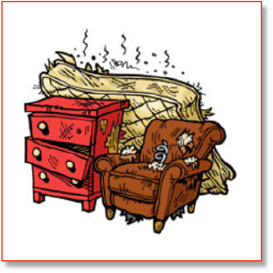

**BULK ITEMS**

**ONE BULK ITEM PER WEEK**

**All Bulk items include, but not limited to, the following:**

Stoves Air Conditioners Refrigerators Bed Frames

Hot Water Heaters Water Softeners Garbage Disposals Freezers

Dishwashers Dryers Humidifiers Treadmills

Washers

FREON MUST BE REMOVED BY A LICENSED COMPANY AND TAGED WITH DATE OF REMOVAL.

**Bulk items will be picked up the same day as trash.** Freon-based appliances will be picked up at the curb with Freon removed. The service company who removed the Freon must affix a sticker stating the Freon has been removed.

**CARPETING** Rolled and tied in 4-foot sections no heavier than 45lbs. each,

eight rolls per week.

**CARDBOARD** Cardboard boxes may be placed out for pickup, flattened, bundled into stacks, and tied with twine to secure. Cardboard should be no longer or wider than 3 feet and flattened.

**COMPUTERS** Computer monitors, desktops, and printers are all allowed at no extra charge as long as there is no more than one complete unit (monitor, desktop, and printer). Additional items or larger office equipment require bulk item handling if heavier than

50lbs.

**TIRES (AUTO) NO TIRES ACCEPTED.**

**NO AUTO PARTS.**

**NON-COLLECTIBLE** Products such as **ANIMAL WASTE**, Lumber, Demolition material, insecticides, oil, gas, propane tanks, antifreeze, concrete, gravel, dirt, sod, rock, stones, stumps, any car parts, Tires, car batteries, riding mowers, cement (even if attached to something), bricks, roofing shingles, paint cans with paint still in it, oil paint, and similar items are also **unacceptable**.

**See “Hazardous & Electronic Waste Collection” below.**

**Christmas Trees will be picked up until the end of January.**

**Christmas Trees must be bare (no ornaments, no hooks, etc.)**

**HAZARDOUS & ELECTRONIC WASTE**

GENESEE COUNTY METROPOLITAN PLANNING COMMISSION Waste Collection Check dates and locations by calling (810) 762-7744. Any item labeled toxic, corrosive, flammable or reactive are considered hazardous. Many products in your kitchen, bathroom, basement and garage require special disposal procedures. A list is available at [www.gcmpc.org](http://www.gcmpc.org)

Environmental Rubber Recycling Inc. 810-789-1222 for tires.

**2024 WASTE REMOVAL**

**Holiday Schedule**

**New Year’s Day:** Monday, January 1, 2024

**Collection Delayed by one day.**

**Memorial Day:** Monday, May 27, 2024 (No Collection)

**Tuesday-Friday: Service delayed by one day.**

**Independence Day:** Thursday, July 4, 2024 (No Collection)

**Thursday-Friday: Service delayed by one day.**

**Labor Day:** Monday, September 2, 2024 (No Collection)

**Tuesday-Friday: Service delayed by one day.**

**Thanksgiving Day:**  Thursday, November 28, 2024 (No Collection)

**Tuesday-Wednesday: Collection on Schedule**

**Thursday-Friday: Service delayed by one day.**

**Christmas Day:** Wednesday, December 25, 2024 (No Collection)

**Tuesday on Schedule**

**Wednesday-Friday: Service delayed**

**By one day.**

**CALENDAR YEAR 2025 Wednesday, January 1,2025 (No Collection)**

**New Year’s Day Tuesday- on schedule**

**Wednesday- Friday: Service delayed by**

**One day**



**CURBSIDE YARD WASTE REMOVAL**

**YARD WASTE INCLUDES:**

Lawn Clippings

Brush

Thatch

Leaves

Border Edgings

Tree & Plant Pruning

Vines & Garden Clearings

**Rules:**

* Yard waste may be placed in a thirty-five (35) gallon container or smaller, under 50lbs., with at least one handle and yard waste stickers on the front and the back of the container.

* Free Yard Waste Stickers are available at City Hall…limit four per household.
* Yard waste may also be placed in the **2-ply paper yard waste bags**,

which are available in stores. No Plastic bags.

* Bags or containers should weigh no more than 50lbs.
* Brush or branches should be no more than 2 inches in diameter and bundled in 4ft. lengths or smaller.
* Yard waste is picked up from the **first FULL week in April through the last FULL week in November (**weather permitting**).** Contact City Hall for specific beginning and ending dates.

**\*\*Non-Collectible**: gravel, dirt, sod, rock, stones, stumps, cement. **\*\***

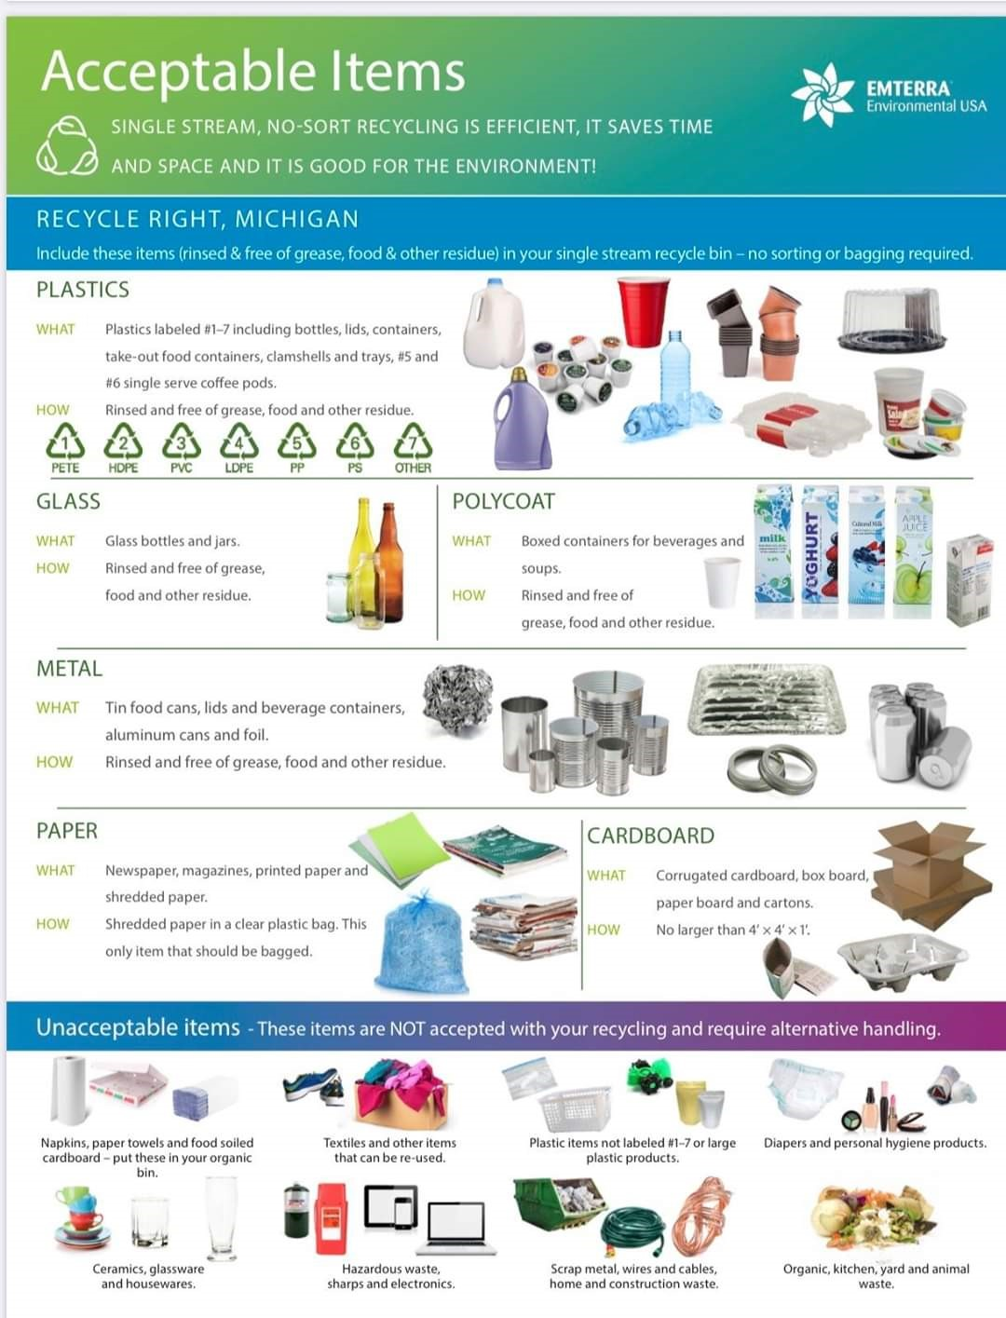

**DUMP PERMITS**

Dump permits with regulations are available at the Burton City Hall.

* Each Burton household is entitled to**: One** (1) free dump permit per month.
* You must reside at said household and it must be your principal residence.
* MUST HAVE PROOF OF RESIDENCY (valid ID, water bill)

**Only Burton residents are allowed to request a permit and must be obtained at Burton City Hall**.

**DUMP PERMIT REGULATIONS:**

* Each Burton household is entitled to **One (1) free dump** permit per month.
* Dump permits are only good for materials coming from the individual’s house. Proper identification is required at the landfill (example: driver’s license or State ID.)
* One dump permit is good for the equivalent of a standard-size bed of a pick-up truckload, under 1000 lbs. If the load is larger than a standard size pick-up bed, you will be charged the difference. You will also be asked to drive back to the landfill. A reflective vest is required to enter landfill.
* Dump permits are good for the following materials:
* Small amounts of household demolition.
* Household refuse.
* Michigan State Law requires that a tarp be used to cover each load.
* You MUST be completely UNLOADED and out before closing time.

If you are unable to use the permit within the calendar month, you must return it to City Hall and a new one will be issued. If you lose your permit, a new one will **NOT** be issued.

**FREON MUST BE REMOVED BY A LICENSED COMPANY AND TAGED WITH DATE OF REMOVAL**.

*If you have any questions, please call the **Brent Run Landfill** 810-639-3077*

**Hours:** **Brent Run Landfill** is open **Monday through Friday from 7:00 a.m. to 3:00 p.m**. **Brent Run Landfill**

**8335 Vienna Rd.**

**Montrose, MI 48457**

Follow I-75 N/US-23 N to M-57 W in Vienna Township.

Take exit 131 from I-75 N/US-23 N

Follow M-57 W to your destination in Montrose Township.

**Burton's Emterra Rewards Program**

****EmterraRewards.com is an affinity program that offers Burton residents savings from local, regional and national businesses just for being an Emterra Environmental USA customer! In addition to the hundreds of saving coupons available, EmterraRewards also gives out thousands of dollars in gift cards every month in random drawings among all participants in the program. It's easy to join. Simply go to [www.EmterraRewards.com](http://www.EmterraRewards.com) and click Sign Up. Choose "Burton" under the community menu and follow the prompts to activate your FREE rewards account. Emterra Rewards provides Burton residents with great savings, random drawings and informative e-blasts to keep the community engaged and saving at places they shop every day. Welcome Burton residents! We look forward to serving you!

**FIRE PERMITS**

**BURNING PERMIT REGULATIONS:**

*General Rules that apply to all types of burning:*

* Burning permits are issued for one and two-family dwellings, residential only. No commercial permits are available.
* Permits issued for a household require the burning to take place at that household only.
* **You must have your permit on hand and available any time you are burning**.
* An adequate fire line shall be made around the area to be burned and the fire shall be always attended.
* There shall be always a garden hose or an adequate method of extinguishment on hand while the fire is burning.
* **Burning in a barrel is not permitted.**
* You may not burn when it is windy.
* **It is illegal to burn in the City of Burton without a burning permit**. Permits may be obtained from the Fire Dept., City Hall, and our Website at www.burtonmi.gov
* A person shall not cause or permit the emission of air contaminates in quantities that cause, alone or in reaction with other contaminates, either of the following:
  + Injurious effects to human health or safety, animal life, plant life of significant economic value, or property. (Smoke and ash shall not be a nuisance to neighbors)
  + Unreasonable interference with the comfortable enjoyment of life and property.

**OPEN BURNING PERMIT REGULATIONS:**

* Burning permitted only for brush, tree limbs and garden debris.
* **No leaves, grass or building materials**
* You are allowed **four** **(4), three consecutive day**, **OPEN BURN PERMITS** per household per year.
* Open Burning must be fifty (50)feet from any building or structure.
* An adequate fire line shall be made around the area to be burned and the fire shall be always attended.
* There shall be always a garden hose or an adequate method of extinguishment on hand while the fire is burning.
* **Burning in a barrel is not permitted**.
* The burning pile shall not exceed an area of four feet by five feet - (4’x5’); anything larger will be considered illegal.
* **Fires must be extinguished by sundown.**

Any property loss caused by any person or persons open burning, either by permit or illegally, is the responsibility of that person and they may be held liable for all losses.

If you are unable to burn on the days your open burn permit is issued, you may receive an extension. Open burning permit extensions are granted by calling the City of Burton Fire Department or City Hall within thirty - (30) days of issuance.

**PERSONS FOUND IN VIOLATION OF THESE BURNING RULES MAY HAVE THEIR PERMIT REVOKED, BURNING PRIVILEGES SUSPENDED AND BE CHARGED FOR THE EXPENSE OF THE FIRE RUN.**

**RECREATIONAL BURNING PERMIT:**

* **Burning is permitted for seasoned wood only.**
* **No leaves, grass, garden debris or building materials**.
* **RECREATIONAL BURNING PERMITS** are annual permits that are good for an entire calendar year and expire on December 31 regardless of the issue date.
* Recreational Burning must be twenty-five (25)feet from any building or structure.
* The burning pile shall not exceed an area of three foot by three foot – (**3’x3’**); anything larger will be considered illegal.
* **Fires shall be extinguished by 1:00 am.**
* Any property loss caused by any person or persons with a Recreational Burn, either by permit or illegally, is the responsibility of that person and they may be held liable for all losses.

**PERSONS FOUND IN VIOLATION OF THESE BURNING RULES MAY HAVE THEIR PERMIT REVOKED, BURNING PRIVILEGES SUSPENDED AND BE CHARGED FOR THE EXPENSE OF THE FIRE RUN.**



**UPCOMING EVENTS**

**UPCOMING EVENTS**

(All events are tentative and subject to change)

February 17,2024 Hot Fudge Run **

March 23,2024 Easter Egg Hunt – Atherton Schools

May 27,2024 Memorial Day Festivities – City Hall

May 27,2024 Memorial Day 5k Run/Walk

June 1,2024 Burton Youth League – Atherton Schools Fields

October 26,2024 Trick or Treat Trail – Bentley High School

November 1,2024 Christmas Decorating Contest (Ends: December 8)

November 9,2024 Veterans Honor Run

November 11,2024 Ceremony (11:11am @ Veterans Memorial)

November 30,2024 Christmas Tree Lighting

December 7,2024 Pizza with Santa – Bendle High School

(**not a Parks & Rec Event, Burton Race Series Event)

**UPCOMING PARKS & REC MEETINGS FOR 2023 MEETINGS ARE AT 5:30PM THE SECOND WEDNESDAY OF EACH MONTH**

January 10,2024 July 10,2024

February 14,2024 August 14,2024

March 13,2024 September 11,2024

April 10,2024 October 9,2024

May 8,2024 November 13,2024

June 12,2024 December 11,2024

**For more information or if you would like to become a sponsor,**

**contact Amy Clous (City of Burton Parks & Rec Director)**

**at (810)743-1500 ext. 1099**

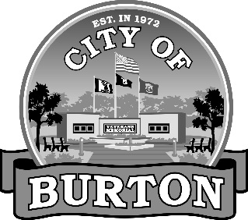

**CITY OF BURTON**

**AUTOMATIC BILL PAYMENT PROGRAM**

The City of Burton is offering an automatic bill payment program for our utility customers. This is a convenient way to pay your utility bill without the worry of missing a payment and being subject to delinquent fees. By signing the authorization below, your payments will be deducted from your checking or saving account on the due date at no cost to you. For more information, call the City Treasurer’s Office at (810) 743-1500.

Customers who would like to utilize this service must complete the authorization agreement listed below and return it to City of Burton, 4303 S. Center Rd., Burton, MI 48519.

**UTILITY PAYMENT AUTOMATIC TRANSFER AUTHORIZATION**

**BANK/CREDIT UNION**

Name of Bank/Credit Union _________________________________________________

City _________________ State _______________ Zip Code _______________

Routing/ABA No. _________________________________________________________

Bank/Credit Union Account Number _______________________________________

Type of Account (must check one)  Checking  Savings

**UTILITY ACCOUNT INFORMATION**

Print Name(s) ____________________________________________________________

________________________________________________________________________

Utility Account # Service Address

________________________________________________________________________

Home Phone Number Cell Phone Number

**AUTHORIZATION**

I (we) hereby authorize the City of Burton to initiate debit entries to my (our) account at the bank/credit union named above. The debit to my (our) account will be on the 15th day of the month that my utility account balance is due.

This authorization is to remain in full force and effect until the City of Burton and the above-named bank/credit union have received written notification or until utility service is terminated. Insufficient funds will follow the same City policy as a “non-sufficient funds check”.

Signature Date